|  |
| --- |
| **WeatherAPI Key-** |
| <https://home.openweathermap.org/api_keys> |
| 75edc1630147aa0385bed4ff7c78bcea |

**Configure LUIS API**

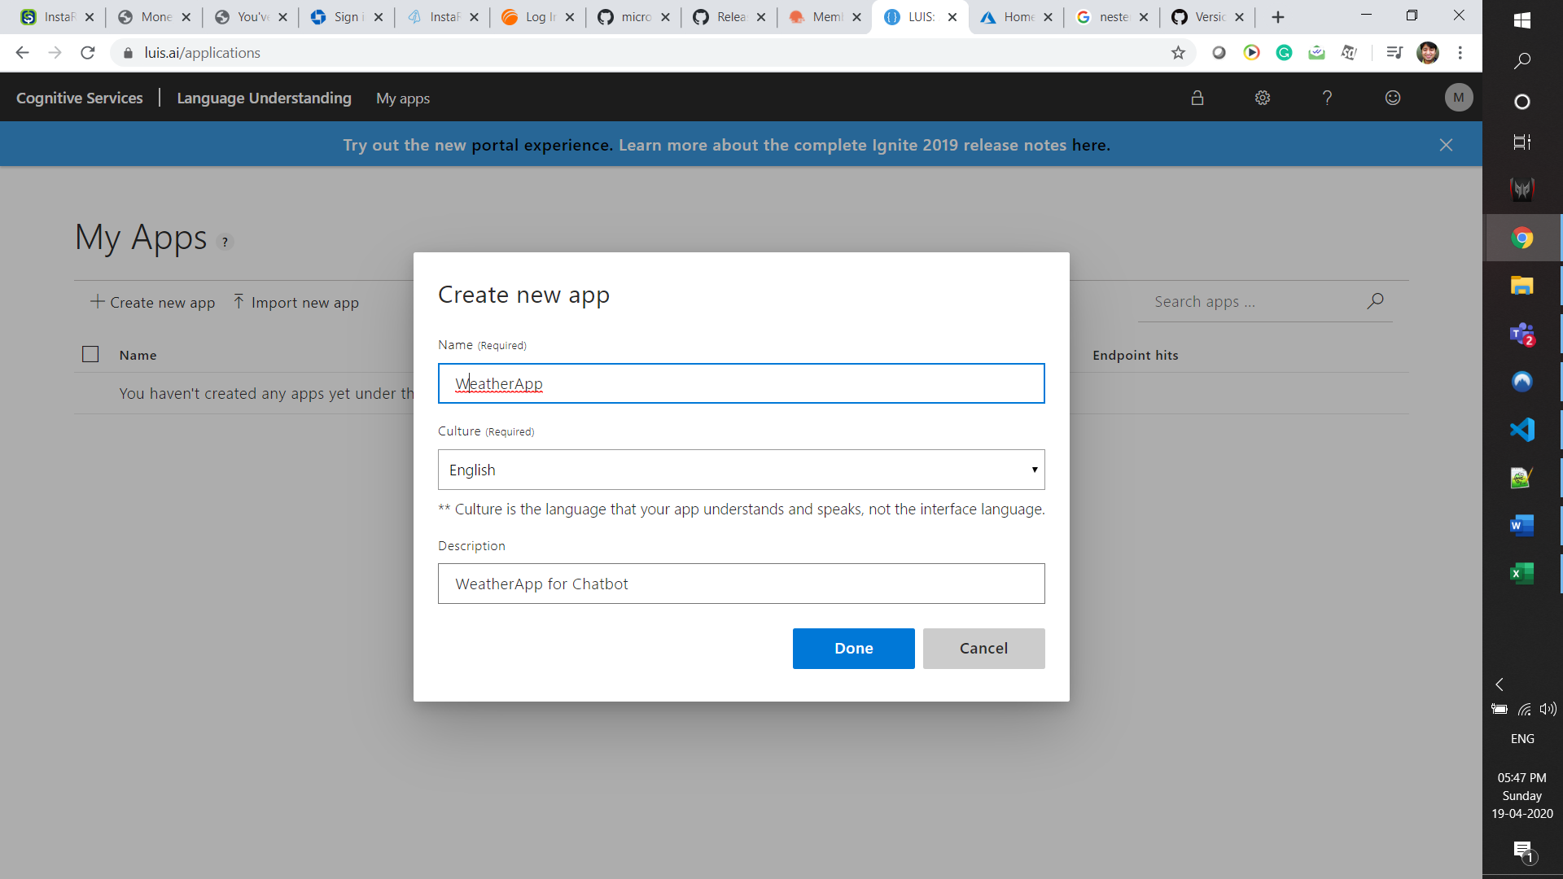

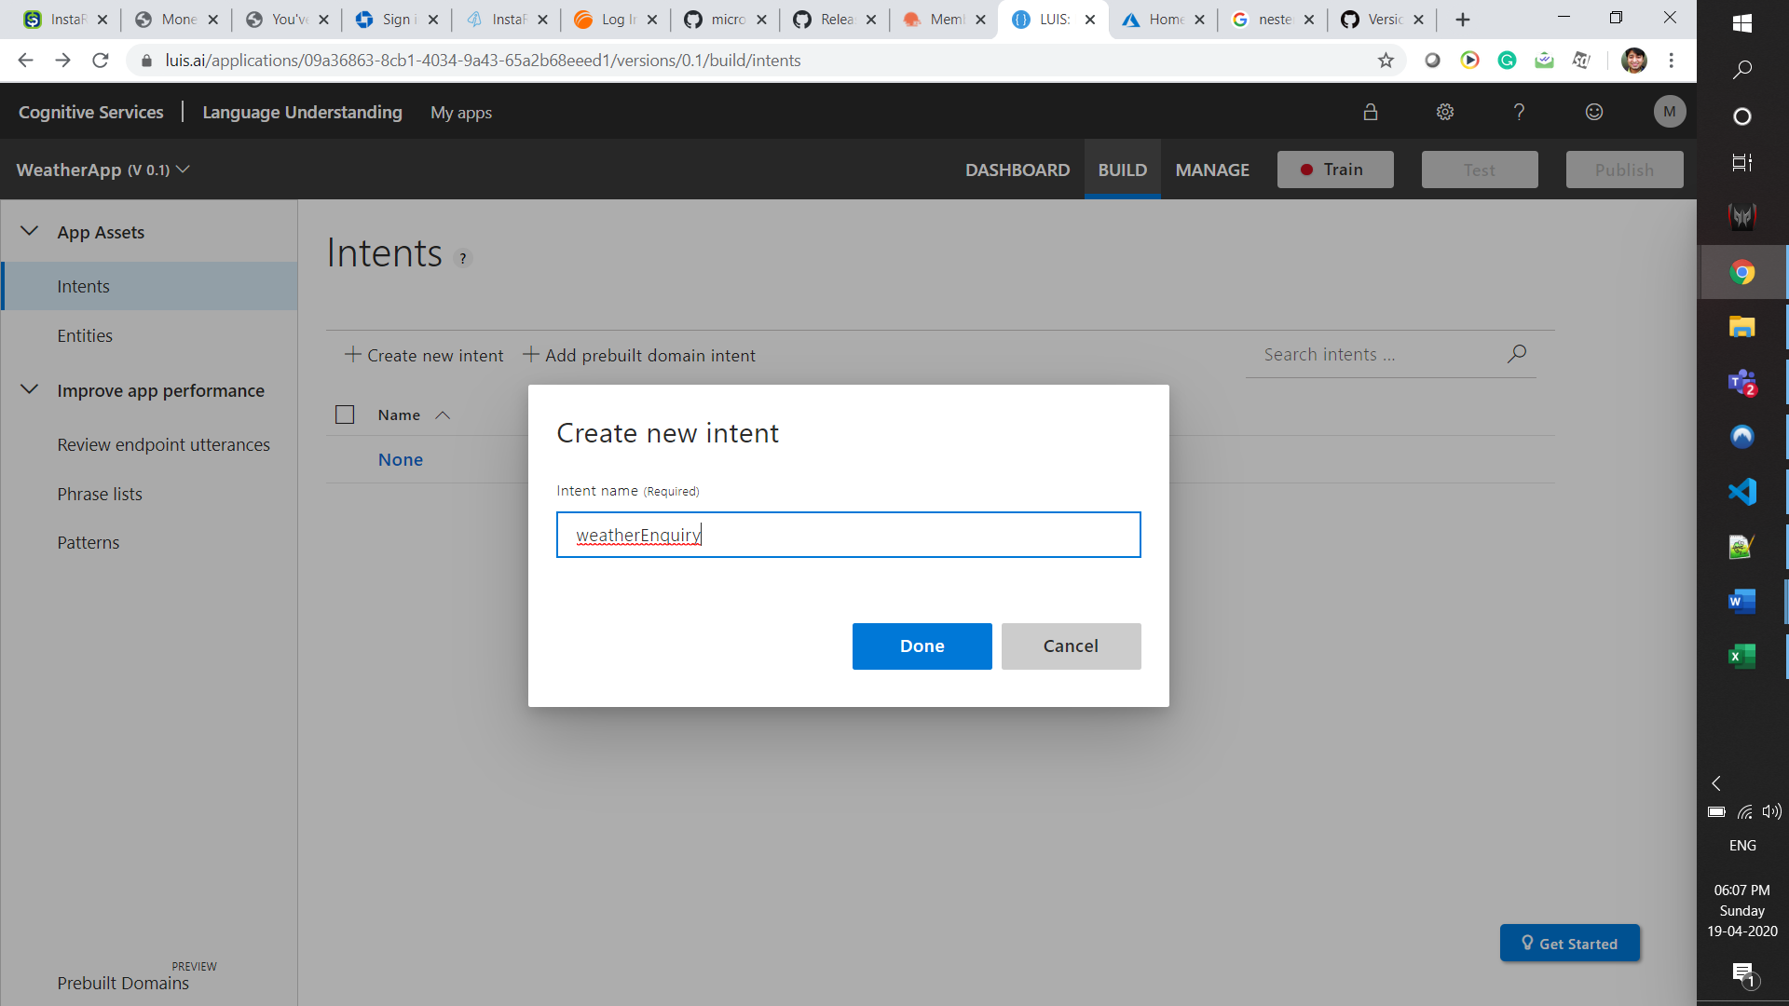

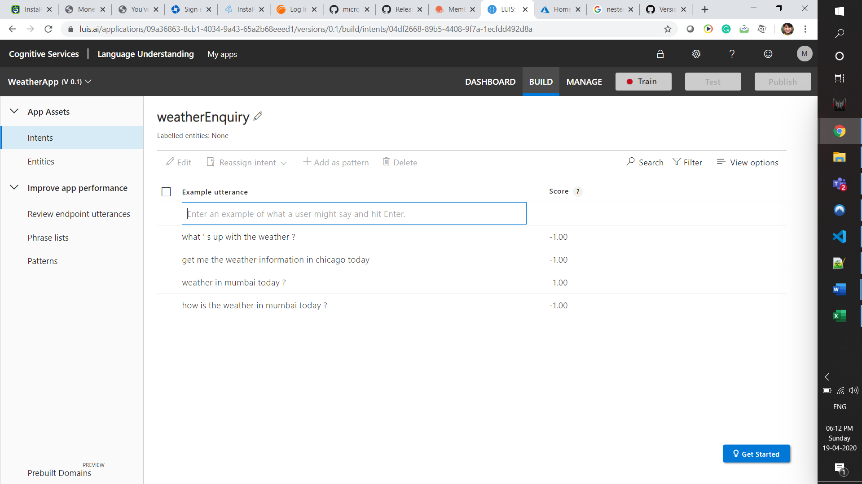

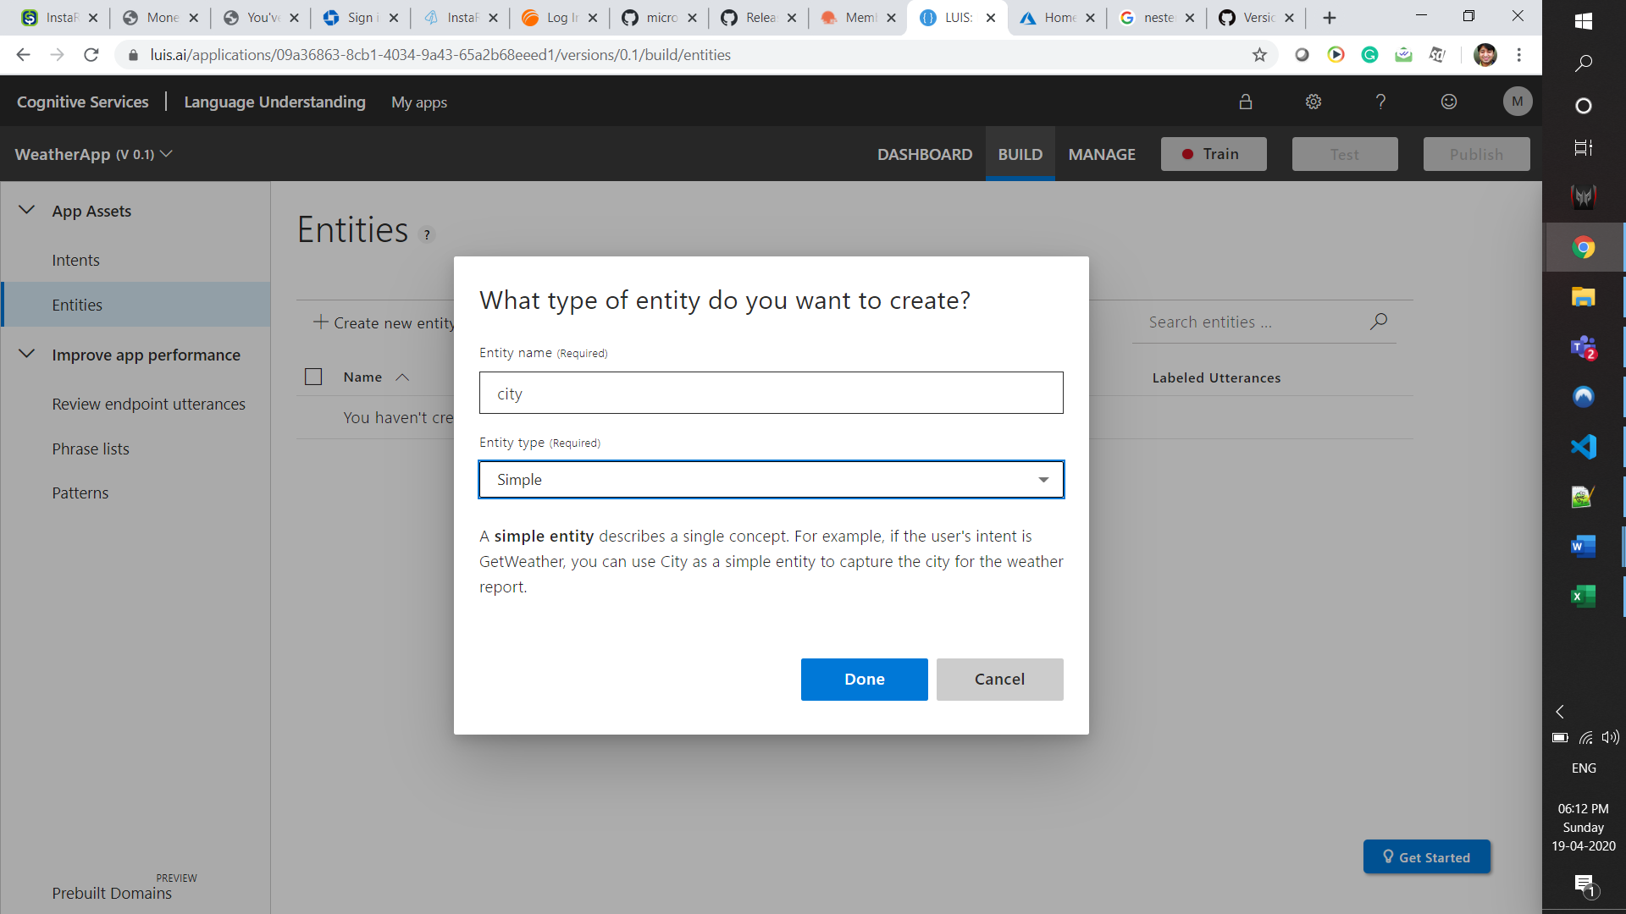

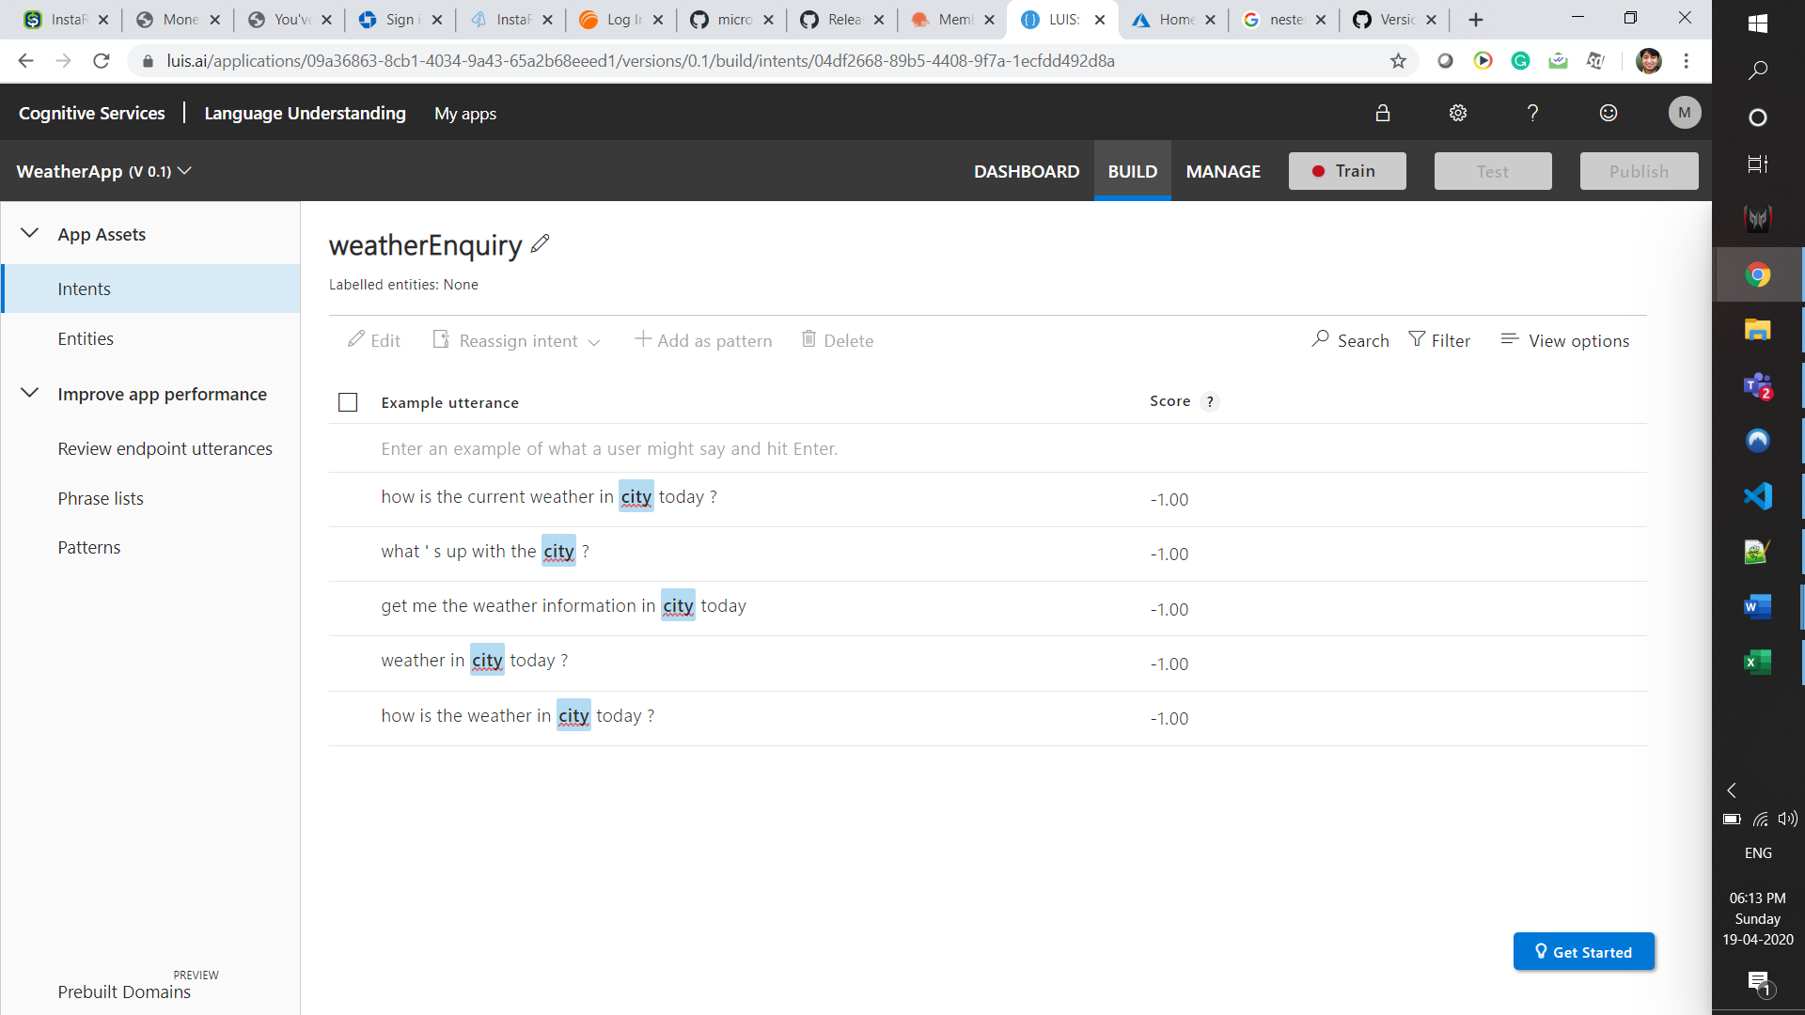

Click Train. The Train icon turns green.

**Take details from Prediction Resources -**

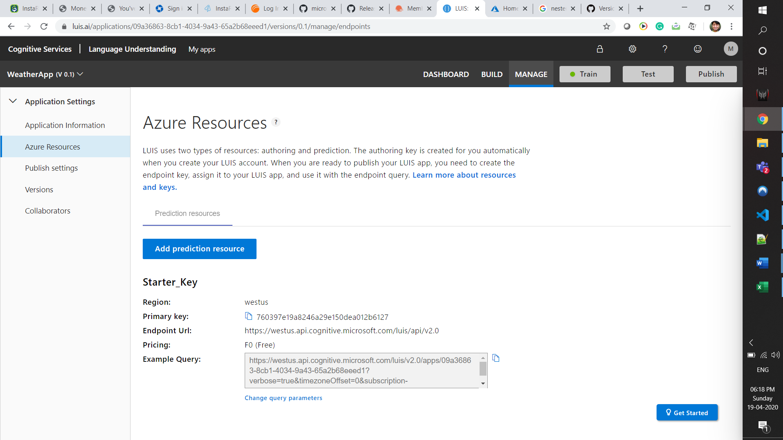

Click on Test to test some utterances.

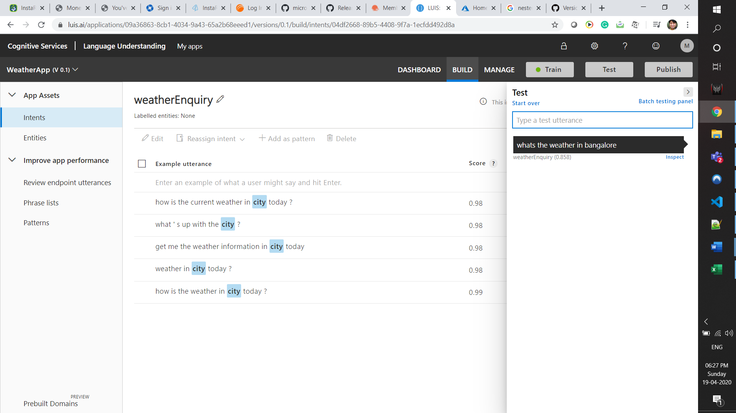

Clicking on Inspect with show the identified intent and Entity –

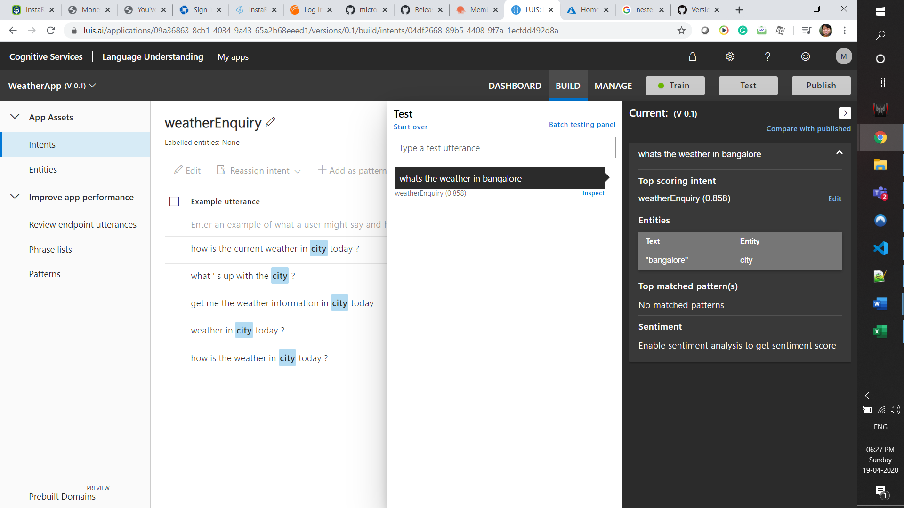

Click PUBLISH TO Publish the app-

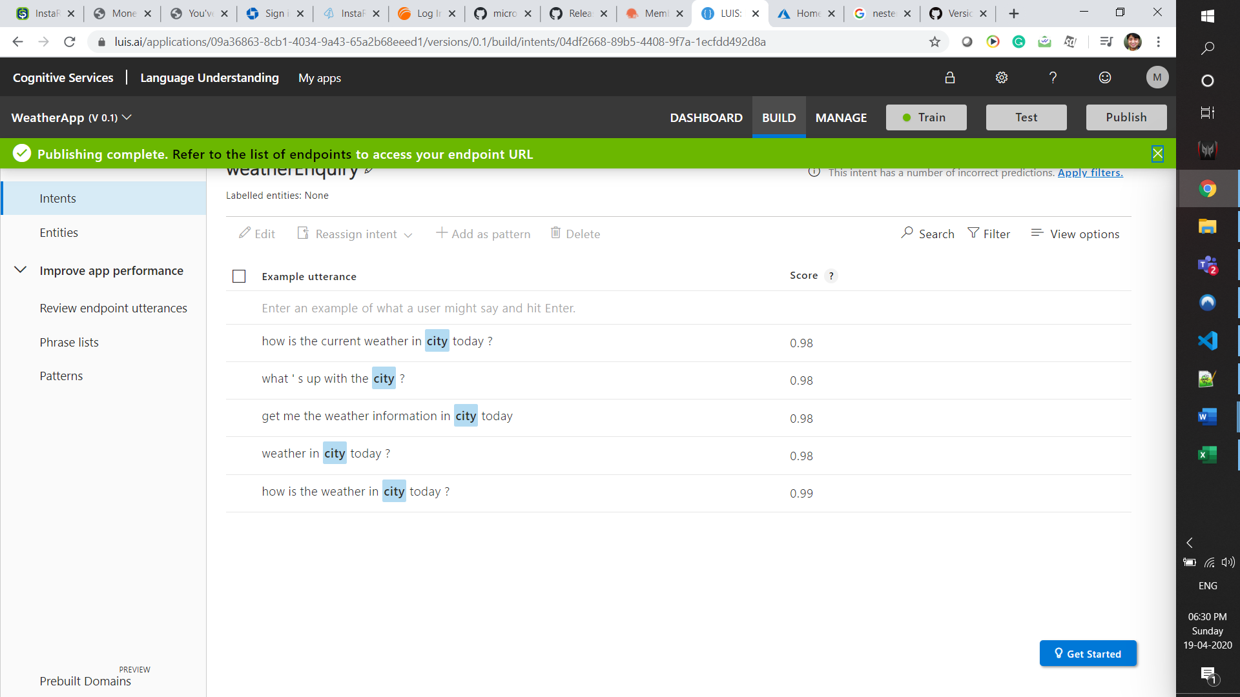

Notedown the Azure Resources details. These will be used on the App

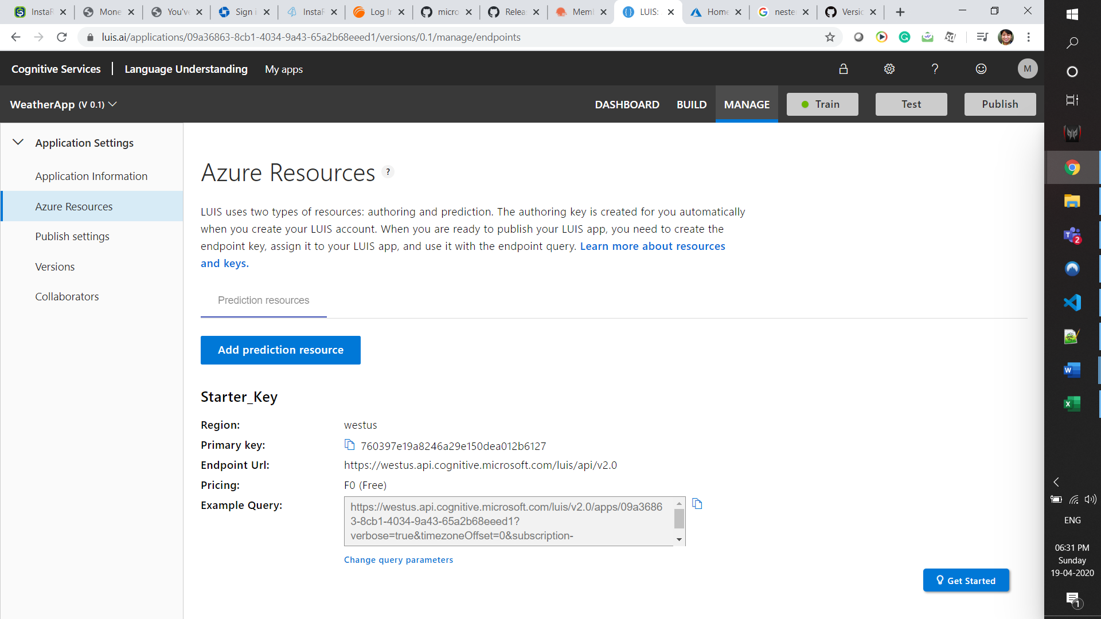

Note the APP ID from the App Info section

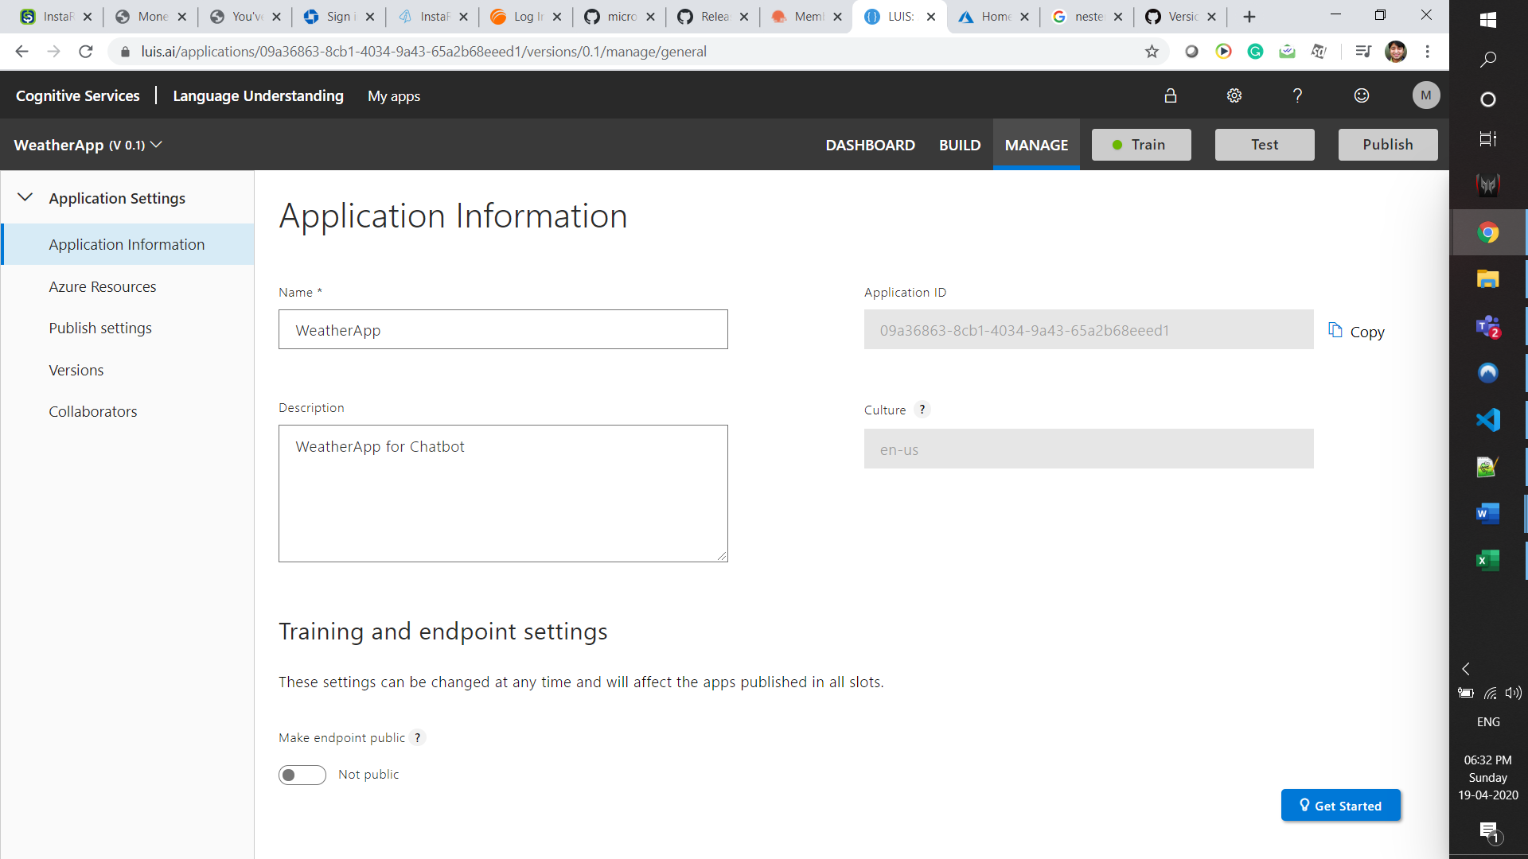

AppID/LUIS_APP_ID - 09a36863-8cb1-4034-9a43-65a2b68eeed1

Azure LUIS -

Starter_Key

Region:

westus

Primary key/LUIS_ENDPOINT_KEY:

760397e19a8246a29e150dea012b6127

Endpoint Url:

https://westus.api.cognitive.microsoft.com/luis/api/v2.0

Pricing:

F0 (Free)

Example Query:

https://westus.api.cognitive.microsoft.com/luis/v2.0/apps/09a36863-8cb1-4034-9a43-65a2b68eeed1?verbose=true&timezoneOffset=0&subscription-key=760397e19a8246a29e150dea012b6127&q=

Change query parameters

|  |
| --- |
| **For flask code** |
| Download following dependencies - |
|  |
| https://github.com/microsoft/botbuilder-python |
| pip install - |
| botbuilder-ai |
| botbuilder-applicationinsights |
| botbuilder-azure |
| botbuilder-core |
| botbuilder-dialogs |
| botbuilder-schema |
| botframework-connector |
| Flask |
| Verify that dependecies are installed. pip  Change config.ini using the variables identified above |

**Execute the Python-**

|  |  |
| --- | --- |
| logger.py - | Holds logic to log the conversations |
| config.ini - | login creds for luis app and weather weather API and LUIS API credentials |
| luisApp.py |  |

Execute the app.py and it will generate a http link for localhost

**For testing the app-**

|  |
| --- |
| Install |
| https://github.com/Microsoft/BotFramework-Emulator/releases/ |
| Download relevant version- windows-setup.exe |

Open the emulator App and pass the Bot URL as –

[http://localhost:<portname>/<path](http://localhost:%3cportname%3e/%3cpath) from @app.route in the code>

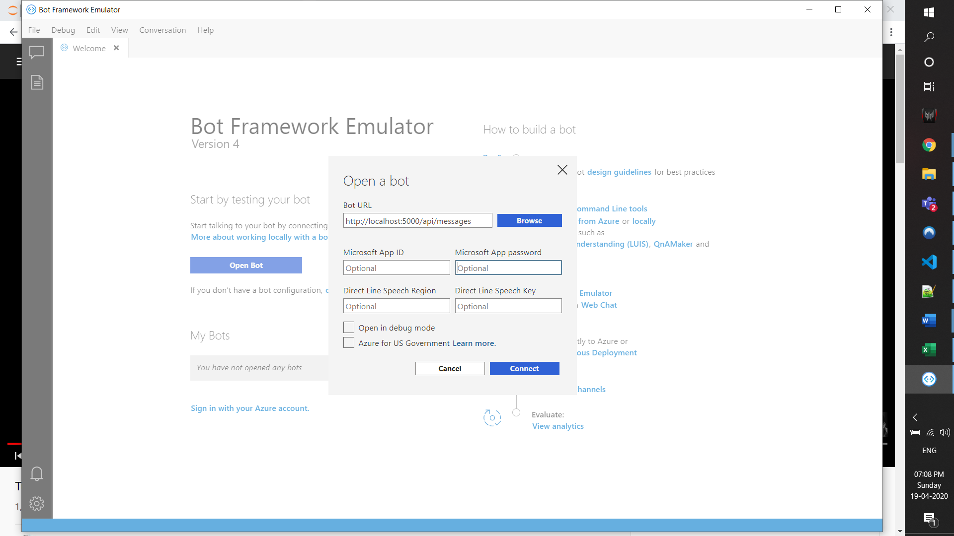

Click Connect

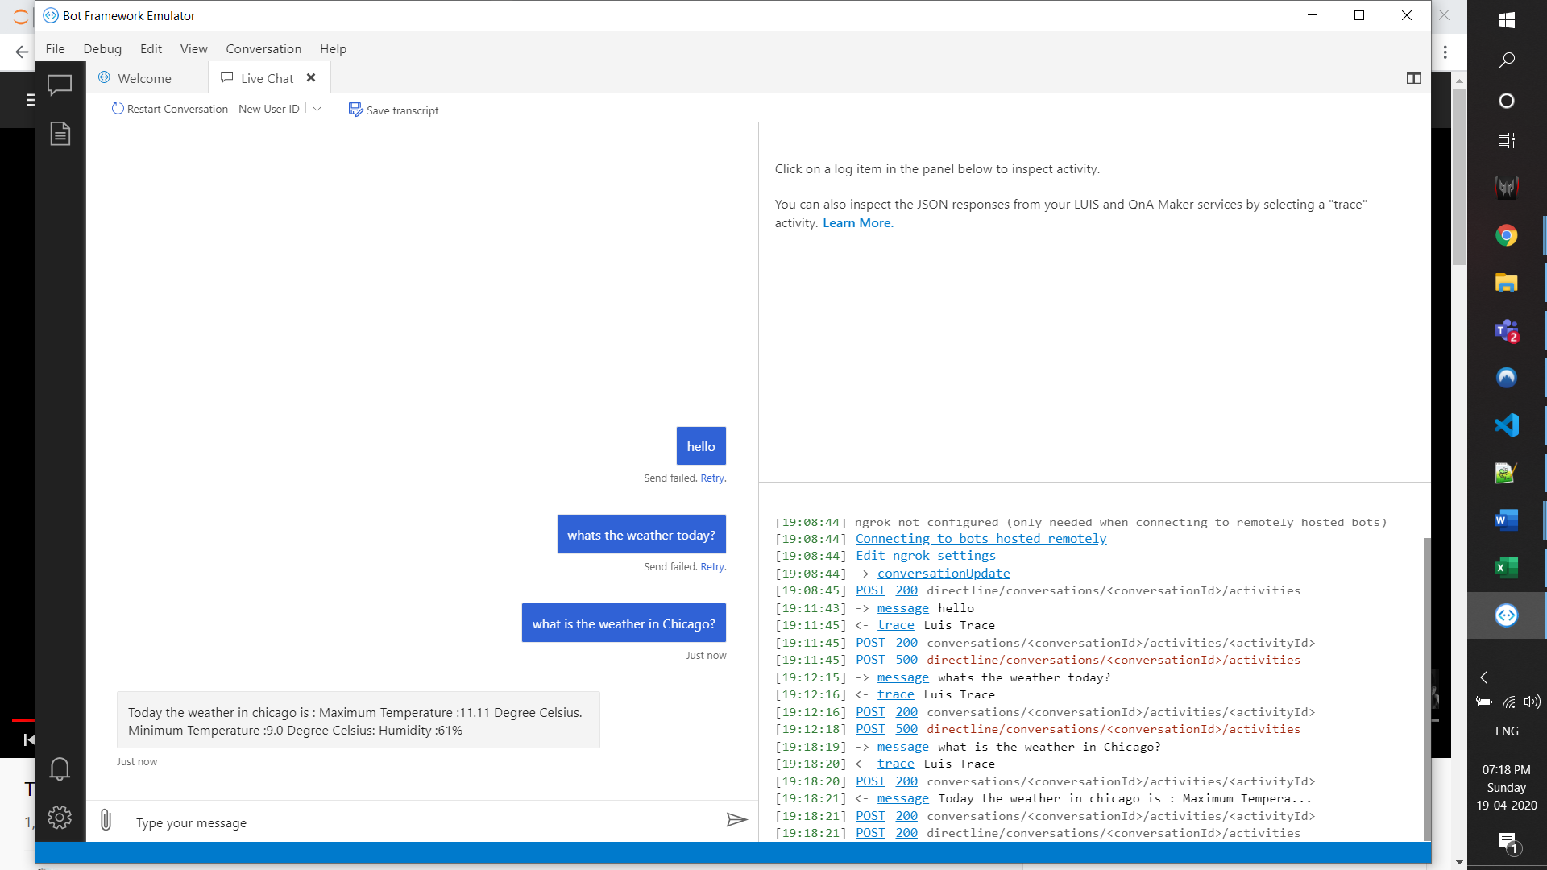

Post 200 means, we have connected.

**Create bot channel Registration**

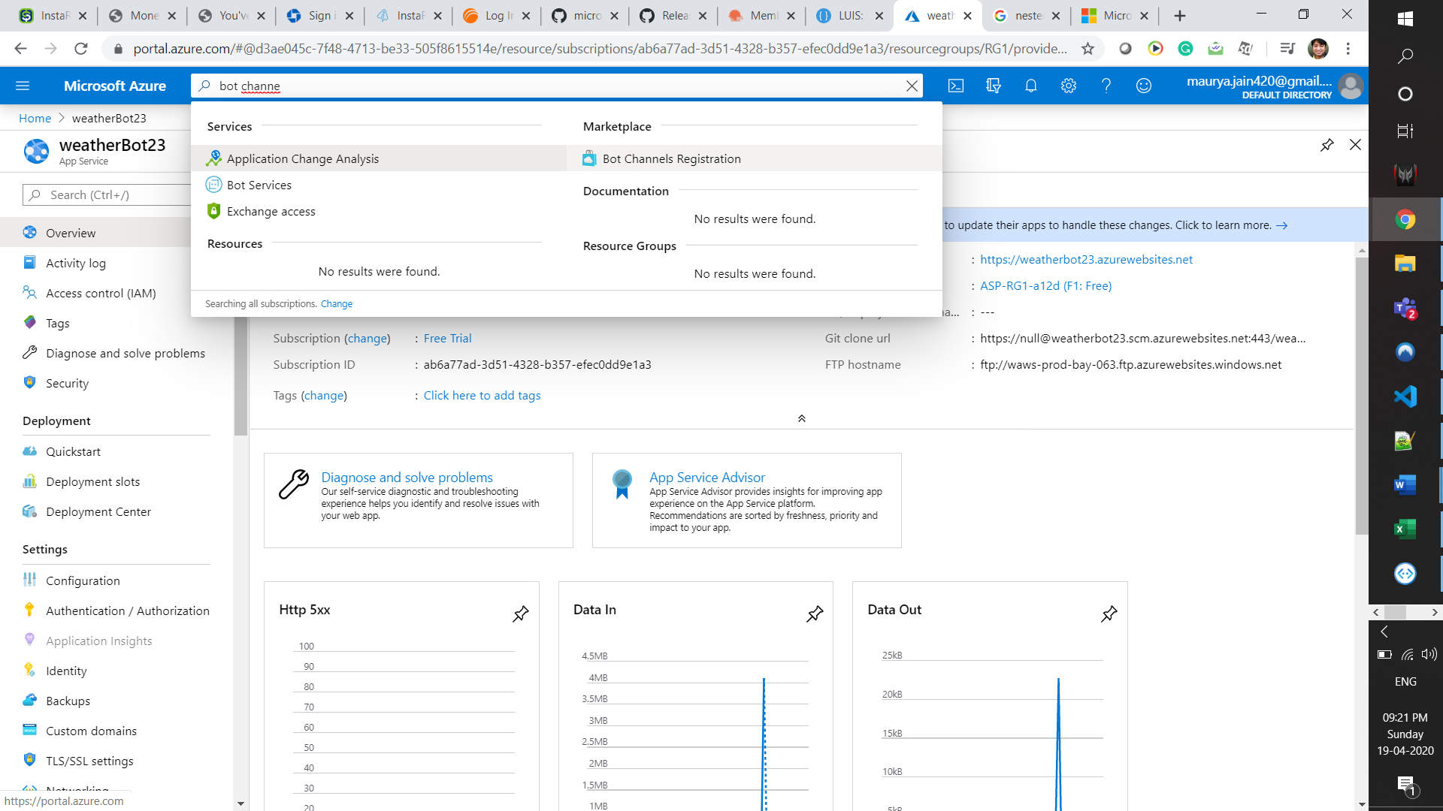

Fill the details.

Choose the F0 pricing tier.

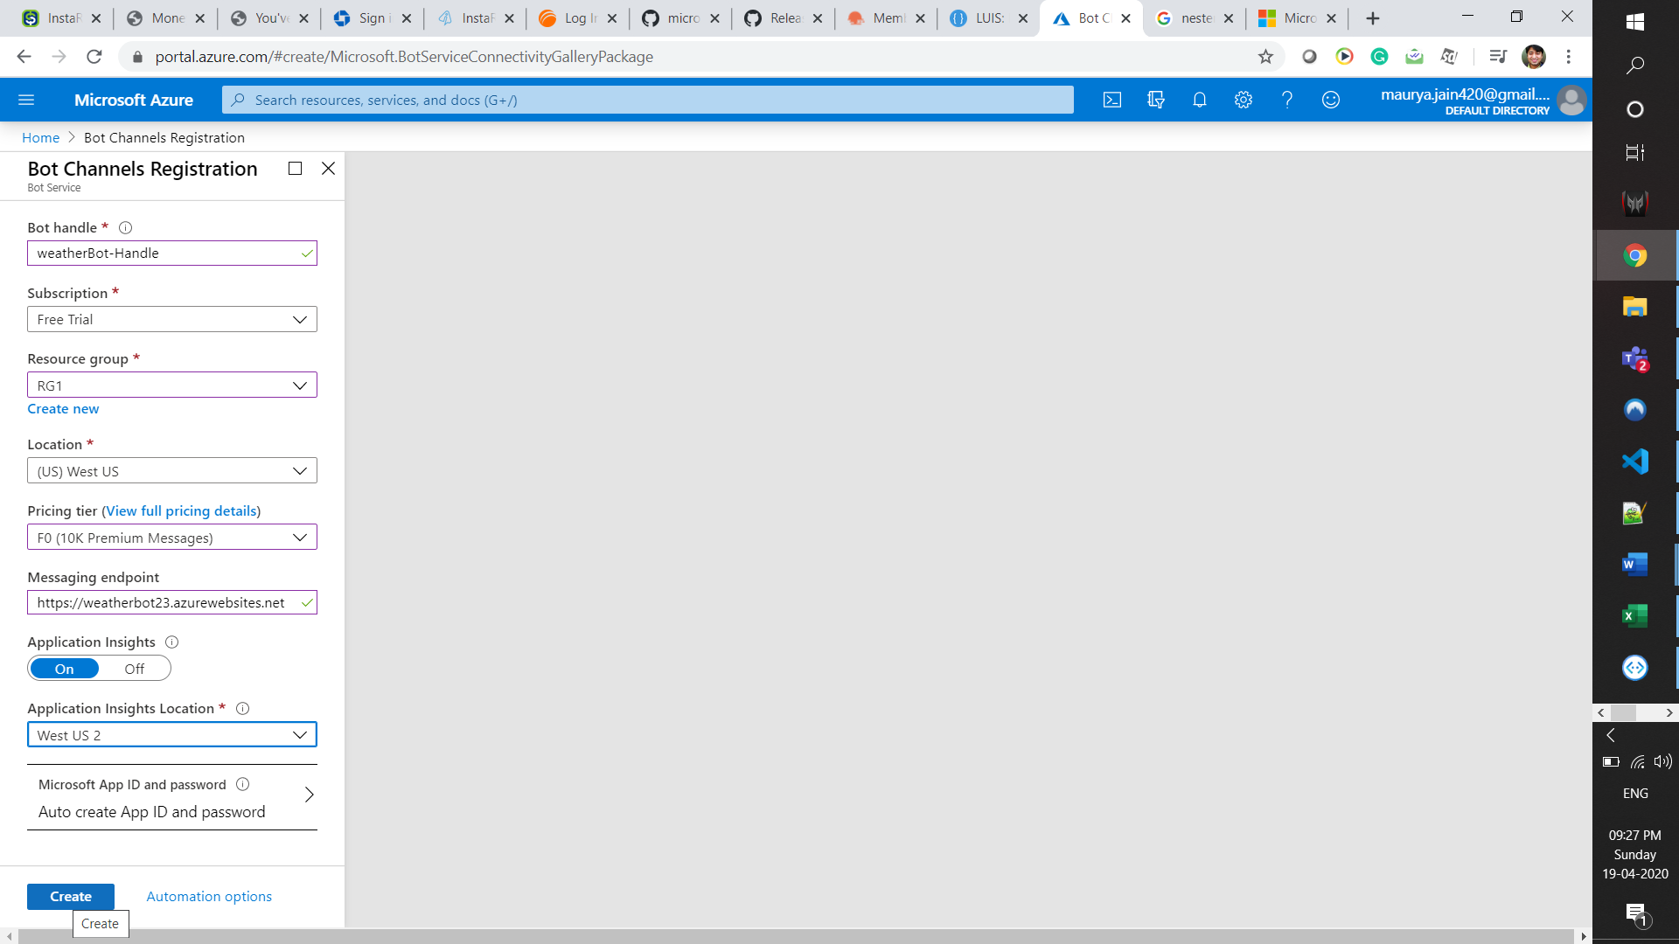

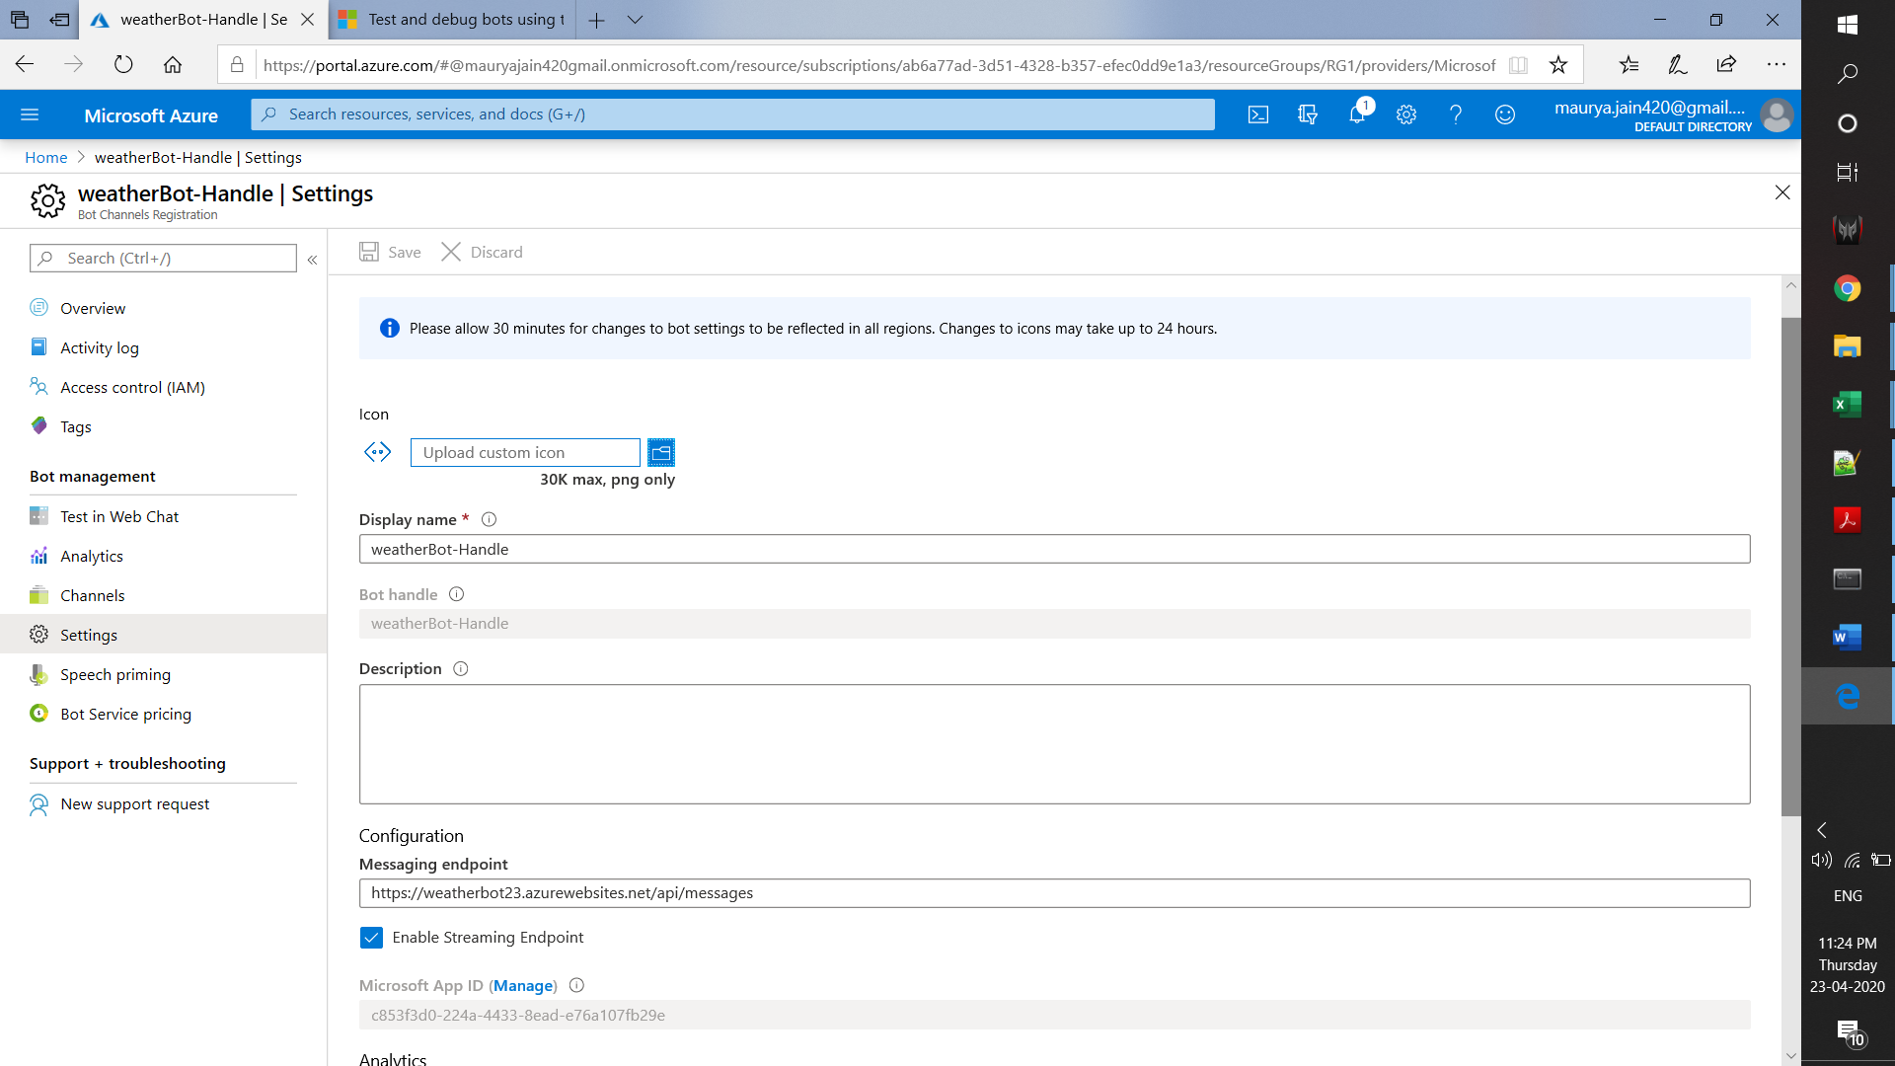

**Deployment on Telegram**

* Open the telegram app and search for botfather(it is an inbuilt bot used to create other bots)
* Start a conversation with botfather and enter /newbot to create a newbot.
* Give a name to your bot
* Give a username to your bot, which must end in _bot.
* This generates an access token. Enter that access token after clicking the telegram channel in your bot app and click save.

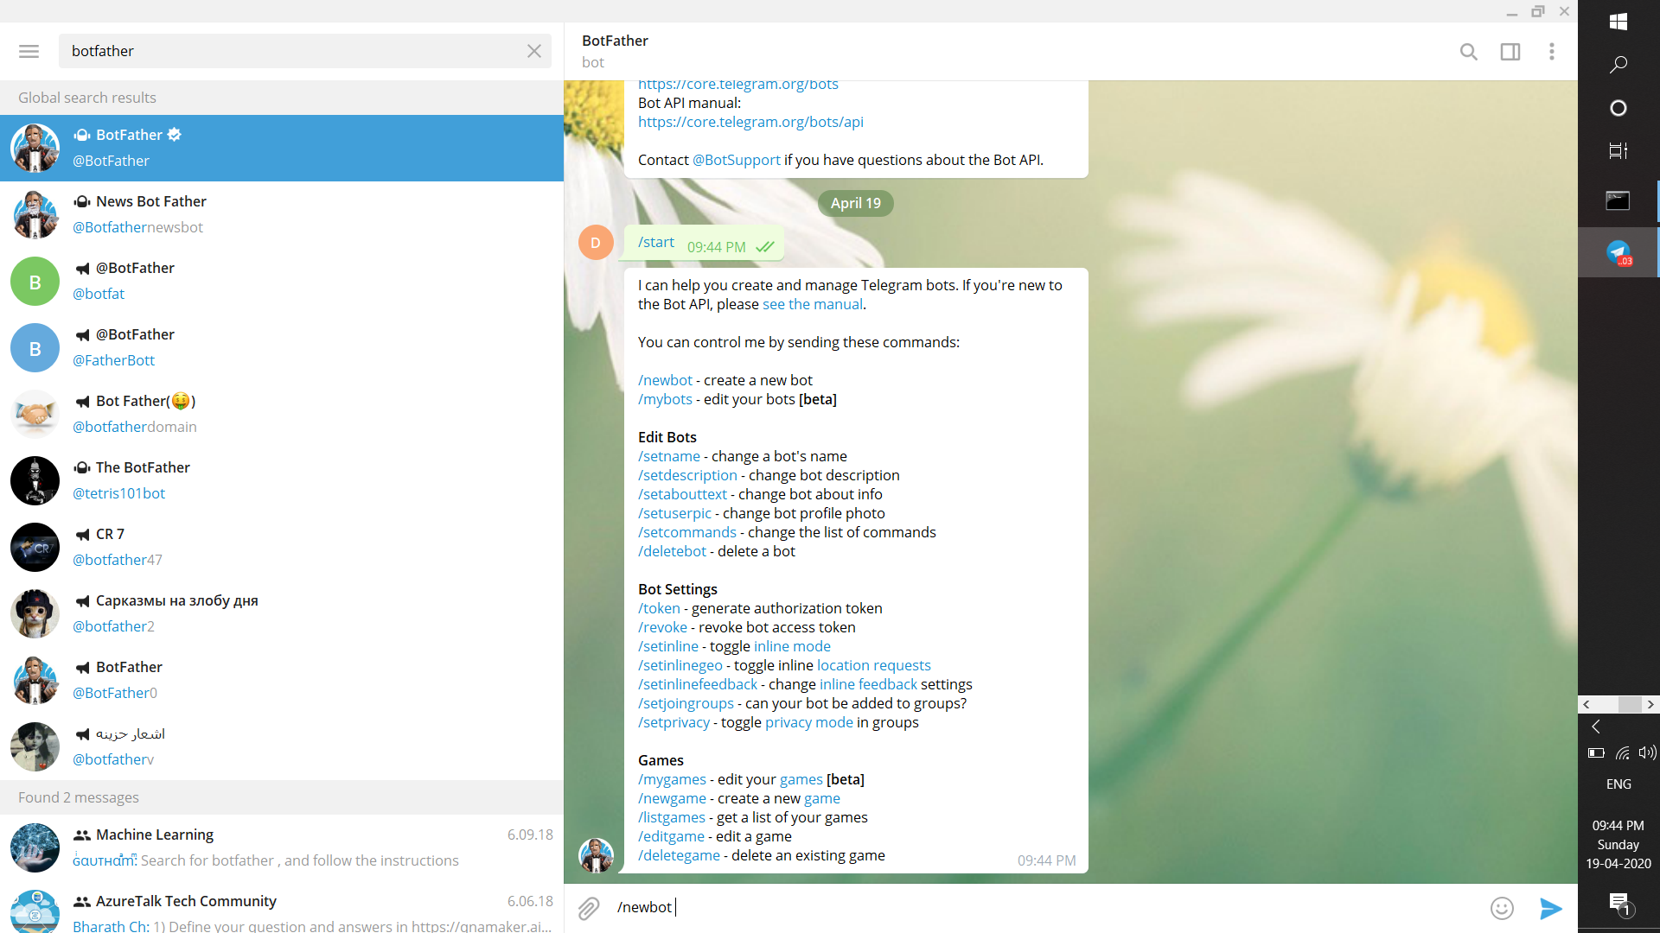

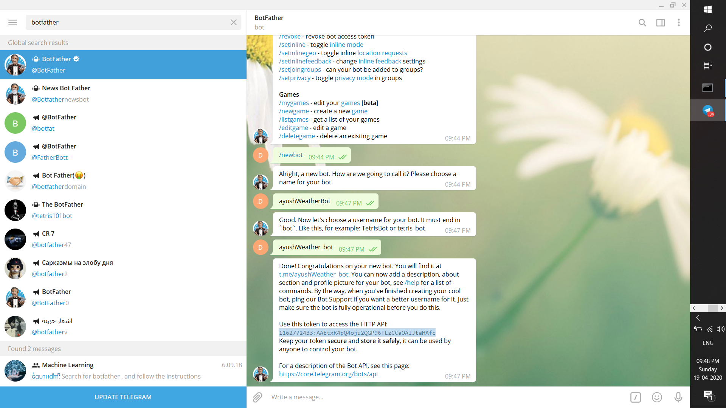

1162772433:AAEtxR4pQ4oju2QGP96TLzCCaOAIJtaHAfc1